 | Thomas Mitchell Primary School

Yard Duty and Supervision Policy

 | Help for non-English speakers  If you need help to understand the information in this policy, please contact Thomas Mitchell Primary School on 03 9706 2254 or thomas.mitchell.ps@education.vic.gov.au.

Purpose
To ensure school staff understand their supervision and yard duty responsibilities.

Scope
This policy applies to all teaching and non-teaching staff at Thomas Mitchell Primary School, including education support staff, casual relief teachers and visiting teachers.

Policy
Appropriate supervision is an important strategy to monitor student behaviour and enables staff to identify and respond to possible risks at school as they arise. It also plays a vital role in helping schools to discharge their duty of care to students.
The principal is responsible for ensuring that there is a well organised and responsive system of supervision and yard duty in place during school hours, before and after school, and on school excursions and camps and other school activities.
School staff are responsible for following reasonable and lawful instructions from the principal, including instructions to provide supervision to students at specific dates, times and places. Supervision should be undertaken in a way that identifies and mitigates risks to child safety.

Before and after school
Thomas Mitchell Primary School’s grounds are supervised by school staff from 8:45 am until 9am and 3.30pm until 3:45 pm. Outside of these hours, school staff will not be available to supervise students.
Before and after school, school staff will supervise the front of the school, Hardcourts, Soccer Pitch, and Playgrounds.
Parents and carers will be advised through our school website, Compass, and regular reminders in our newsletter that they should not allow their children to attend Thomas Mitchell Primary School outside of these hours. Families are encouraged to contact our school for more information about the before and after school care facilities available to our school community.
If a student arrives at school before supervision commences at the beginning of the day, the principal or nominee staff member will, as soon as practicable, follow up with the parent/carer to:
- advise of the supervision arrangements before school
- request that the parent/carer make alternate arrangements.
If a student is not collected before supervision finishes at the end of the day, the principal or nominee staff member will consider whether it is appropriate to:
- attempt to contact the parents/carers
- attempt to contact the emergency contacts
- place the student in an out of school hours care program (if available and the parent consents)
- contact Victoria Police and/or Child Protection to arrange for the supervision, care and protection of the student.

Yard duty
All staff at Thomas Mitchell Primary School are expected to assist with yard duty supervision and will be included in the weekly roster.
The Daily Organiser is responsible for preparing and communicating the yard duty roster on a regular basis. At Thomas Mitchell Primary School, school staff will be designated a specific yard duty area to supervise.

Yard duty zones
The designated yard duty areas for our school as at Term 4 2025 are:
Area
Front of school/Portables
Courtyard/Portables
Hardcourts/4-6 Soccer Pitch/Playground
P-2 Playground/Soccer Pitch
Oval – Years 3 – 6, lunchtime only

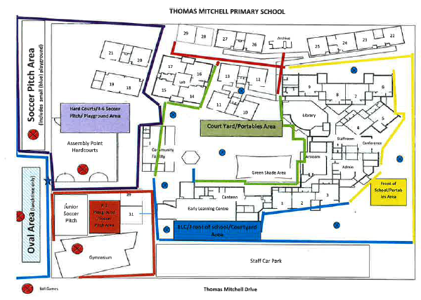

Yard duty equipment
School staff must:
- wear a provided safety/hi-vis vest whilst on yard duty.
- carry the yard duty first aid bag at all times during supervision. The yard duty first aid bag will be stored next to the Lost Property Area
- Carry the yard duty phone when on Oval Duty
Yard duty equipment must be returned after the period of supervision or handed to the relieving staff member.

Yard duty responsibilities
Staff who are rostered for yard duty must remain in the designated area until they are replaced by a relieving staff member.
During yard duty, supervising staff must:
- methodically move around the designated zone ensuring active supervision of all students
- where safe to do so, approach any unknown visitor who is observed on school grounds without a clear legitimate purpose, and ensure they have a visitor pass and have signed in (excluding drop off and collection periods)
- be alert and vigilant
- intervene immediately if potentially dangerous or inappropriate behaviour is observed in the yard
- enforce behavioural standards and implement appropriate consequences for breaches of safety rules, in accordance with any relevant disciplinary measures set out in your school’s Student Engagement and Wellbeing policy
- ensure that students who require first aid assistance receive it as soon as practicable
- log any incidents or near misses as appropriate on Compass.
- if being relieved of their yard duty shift by another staff member (for example, where the shift is ‘split’ into 2 consecutive time periods), ensure that a brief but adequate verbal ‘handover’ is given to the next staff member in relation to any issues which may have arisen during the first shift.
If the supervising staff member is unable to conduct yard duty at the designated time, they should contact the Daily Organiser with as much notice as possible prior to the relevant yard duty shift to ensure that alternative arrangements are made.
If the supervising staff member needs to leave yard duty during the allocated time, they should contact the Daily Organiser but should not leave the designated area until the relieving staff member has arrived in the designated area.
If a relieving or next staff member does not arrive for yard duty, the staff member currently on duty should send a message to the office/call the Daily Organiser and not leave the designated area until a replacement staff member has arrived.
Students will be encouraged to speak to the supervising yard duty staff member if they require assistance during recess or lunchtime.

Classroom
The classroom teacher is responsible for the supervision of all students in their care during class.
If a teacher needs to leave the classroom unattended at any time during a lesson, they should first contact the office/Daily Organiser/Assistant Principal for assistance. The teacher should then wait until another staff member has arrived at the classroom to supervise the class prior to leaving.
When students are required to move around the school, they must do so with at least one other student.

School activities, camps and excursions
The principal and leadership team are responsible for ensuring that students are appropriately supervised during all school activities, camps and excursions, including when external providers are engaged to conduct part or all of the activity. Appropriate supervision will be planned for school activities, camps and excursions on an individual basis, depending on the activities to be undertaken and the level of potential risk involved, and will follow the supervision requirements in the Department of Education Excursions Policy.

Digital devices and virtual classroom
Thomas Mitchell Primary School follows the department’s Digital Technologies - Responsible Use Policy with respect to supervision of students using digital devices.
Thomas Mitchell Primary School will also ensure appropriate supervision of students participating in remote and flexible learning environments while on the school site. In these cases, students will be supervised in the staffroom/Library or other nominated area within the school buildings.

Students requiring additional supervision support
Sometimes students will require additional supervision, such as students with disability or other additional needs. In these cases, the principal or delegate will ensure arrangements are made to roster additional staff as required. This may include on yard duty, in the classroom or during school activities.

Supervision of student in emergency operating environments
In emergency circumstances our school will follow our Emergency Management Plan, including with respect to supervision.
In the event of any mandatory period of remote or flexible learning our School will follow the operations guidance issued by the Department.

COMMUNICATION
This policy will be communicated to our school community in the following ways:
- Included in staff induction processes
- Discussed at staff briefings or meetings, as required
- On TMPS Google Drive
- Included as a reference in our school newsletter each term
Information for parents and students on supervision before and after school is available on our school website.

FURTHER INFORMATION and resources
This policy should be read in conjunction with the following policies on the Department’s Policy and Advisory Library (PAL):
- Child Safe Standards
- Digital Technologies - Responsible Use
- Duty of Care
- Excursions
- Supervision of Students
- Visitors in Schools

Policy REVIEW and Approval
Policy last reviewed | October 2025
Approved by | Principal
Next scheduled review date | Before October 2027
This policy will also be updated if significant changes are made to school grounds that require a revision of Thomas Mitchell Primary School’s yard duty and supervision arrangements.

