 MOBILE PHONES – STUDENT USE
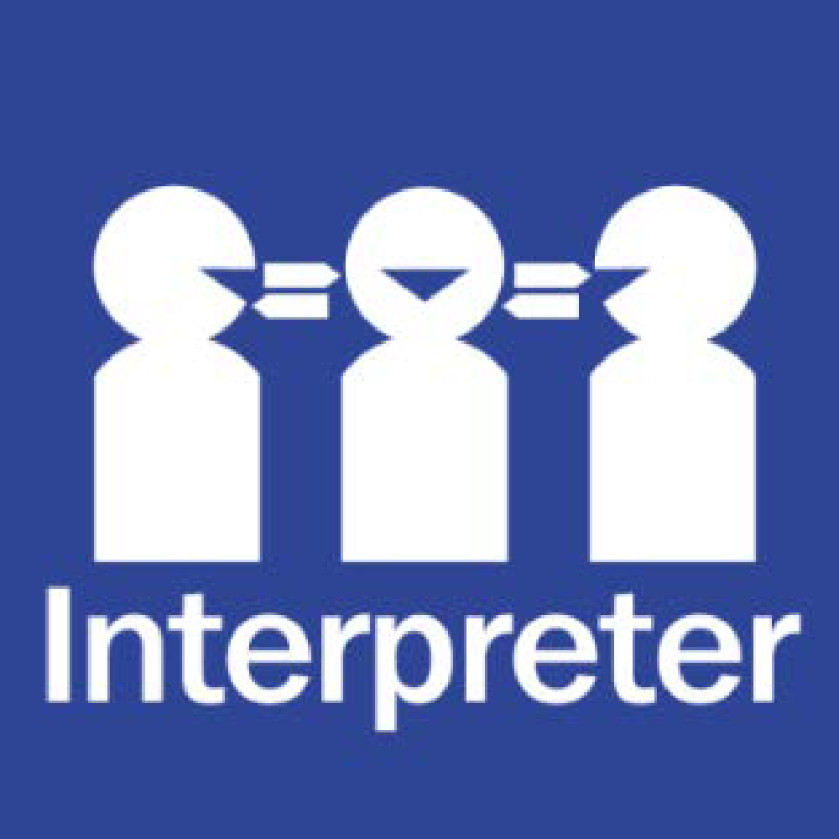
Help for non-English speakers
If you need help to understand the information in this policy please contact
9706 2254.

PURPOSE
To explain to our school community the Department’s and Thomas Mitchell Primary School’s policy requirements and expectations relating to students using mobile phones and other personal mobile devices during school hours.
SCOPE
This policy applies to:
- All students at Thomas Mitchell Primary School and,
2. Students’ personal mobile phones and other personal mobile devices brought onto school premises during school hours, including recess and lunchtime.

DEFINITIONS
A mobile phone is a telephone with access to a cellular (telecommunication) system, with or without a physical connection to a network. For the purpose of this policy, “mobile phone” refers to mobile phones and any device that may connect to or have a similar functionality to a mobile phone such as smart watches.
POLICY
Thomas Mitchell Primary School understands that students may bring a personal mobile phone to school, particularly if they are travelling independently to and from school.
At Thomas Mitchell Primary School:
- Students who choose to bring mobile phones to school must have them switched off and handed to the teacher to be securely stored during school hours
- Exceptions to this policy may be applied if certain conditions are met (see below for further information)
- When emergencies occur, parents or carers should reach their child by calling the school’s office.

Personal mobile phone use
In accordance with the Department’s Mobile Phones — Student Use Policy issued by the Minister for Education, personal mobile phones must not be used at Thomas Mitchell Primary School during school hours, including lunchtime and recess, unless an exception has been granted.
Where a student has been granted an exception, the student must use their mobile phone for the purpose for which the exception was granted, and in a safe, ethical and responsible manner.
Secure storage
Communication devices owned by students at Thomas Mitchell Primary School are considered valuable items and are brought to school at the owner’s (student’s or parent/carer’s) risk. Students are encouraged not to bring a mobile phone to school unless there is a compelling reason to do so. Please note that Thomas Mitchell Primary School does not have accident insurance for accidental property damage or theft. Students and their parents/carers are encouraged to obtain appropriate insurance for valuable items. Refer to the Department’s Claims for Property Damage and Medical Expenses policy.]
Where students bring a mobile phone to school, Thomas Mitchell Primary School will provide secure storage. Secure storage is storage that cannot be readily accessed by those without permission to do so. At Thomas Mitchell Primary School students are required to store their phones in the lockable red cabinet in their classroom.
Enforcement
Students who use their personal mobile phones inappropriately at Thomas Mitchell Primary School may be issued with consequences consistent with our school’s existing student engagement policies -Student Wellbeing and Engagement.
At Thomas Mitchell Primary School inappropriate use of communication devices is any use during school hours, unless an exception has been granted, and particularly use of a mobile phone:
- in any way that disrupts the learning of others
- to send inappropriate, harassing or threatening messages or phone calls
- to engage in inappropriate social media use including cyber bullying
- to capture video or images of people, including students, teachers and members of the school community without their permission
- to capture video or images in the school toilets, changing rooms, swimming pools and gyms
- during exams and assessments
Exceptions
Exceptions to the policy:
- may be applied during school hours if certain conditions are met, specifically,
  - Health and wellbeing-related exceptions; and
  - Exceptions related to managing risk when students are offsite.
- can be granted by the Principal, or by the teacher for that class, in accordance with the Department’s Mobile Phones — Student Use Policy.

The three categories of exceptions allowed under the Department’s Mobile Phones — Student Use Policy are:
1. Learning-related exceptions
Specific exception | Documentation
For students for whom a reasonable adjustment to a learning program is needed because of a disability or learning difficulty | Individual Education Plan

2. Health and wellbeing-related exceptions
Specific exception | Documentation
Students with a health condition | Student Health Support Plan
Students who are Young Carers | A localised student record

3. Exceptions related to managing risk when students are offsite -
This exemption does not apply to students at Thomas Mitchell Primary School
Where an exception is granted, the student can only use the mobile phone for the purpose for which it was granted.
Camps, excursions and extracurricular activities
Thomas Mitchell Primary School will provide students and their parents and carers with information about items that can or cannot be brought to camps, excursions, special activities and events, including personal mobile phones.
Exclusions
This policy does not apply to
- Out-of-School-Hours Care (OSHC)
- Out-of-school-hours events
- Travelling to and from school

COMMUNICATION
This policy will be communicated to our school community in the following ways:
- Available publicly on our school’s website
- Hard copy available from school administration upon request

RELATED POLICIES AND RESOURCES
- Mobile Phones — Student Use Policy
POLICY REVIEW AND APPROVAL
Policy last reviewed | 11 November 2025
Approved by | Principal
Next scheduled review date | November 2029

